## ESG Survey Reporting

**NLP Text Processing: SPACY**

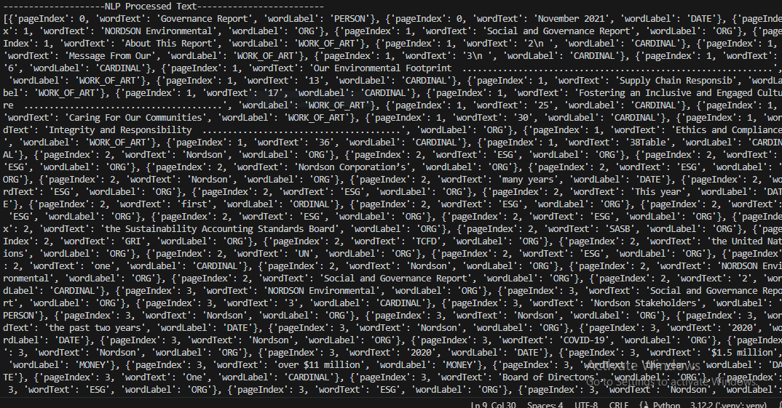

**Endpoint: /esg/benchmark/upload/{entityName}/{esgType}/{esgIndicator}**

Description: Fetch specific ESG indicator for given entity

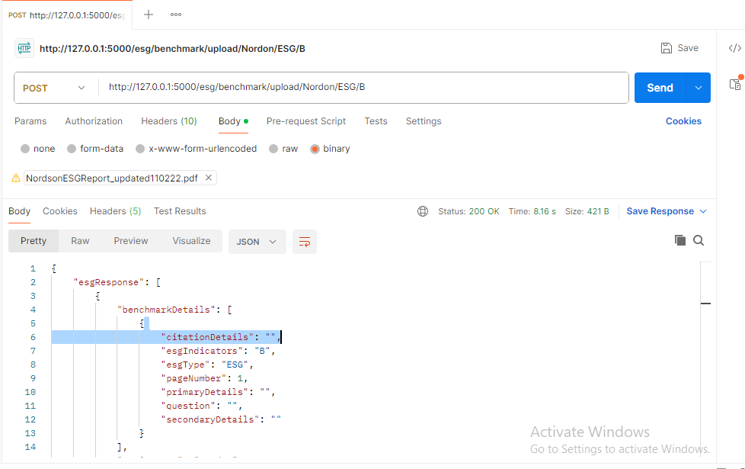

**Endpoint: /esg/benchmark/upload/{entityName}**

Description: Upload ESG for given entity and retrieve all ESG benchmark document

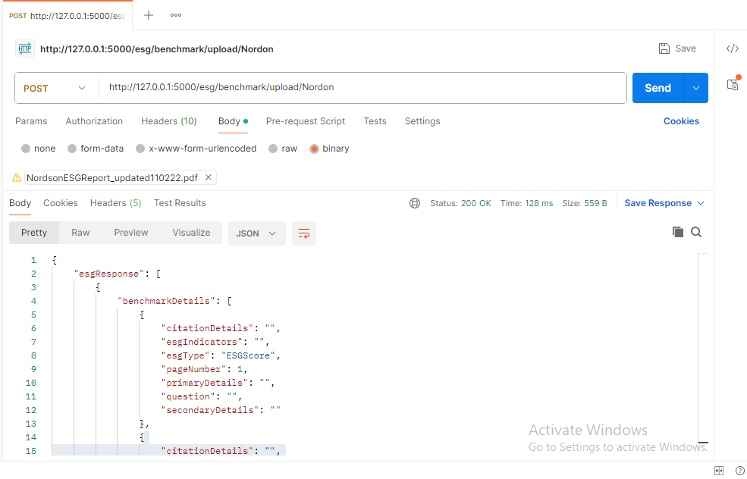

**Endpoint: /esg/benchmark/keepalive**

Description: Find status of the benchakring service

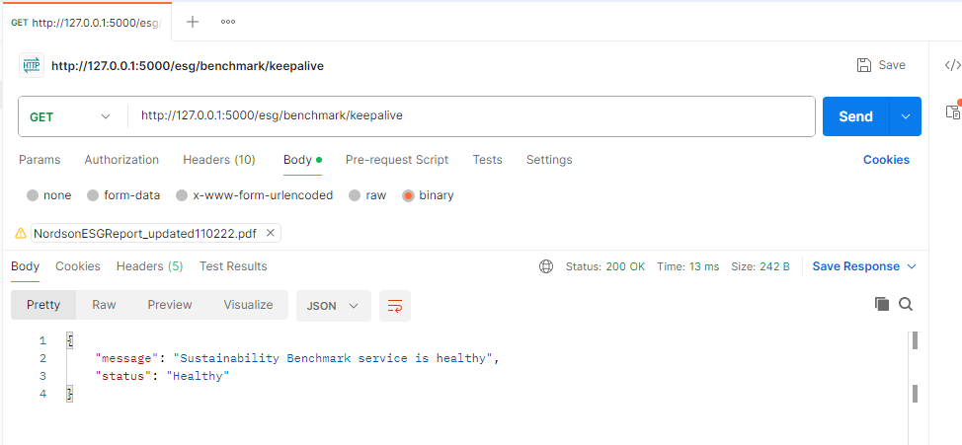

**Endpoint: /esg/benchmark/pdf-report/{entityName}**

Description: get PDF URL for given entity name

